Project Progress

Submission-5

Project Name: **Expression Solver**

Written By: **Alim Ul Karim**(**112 0821 042**) & **Alvee Rahman (**112 0350042)

Contacts: Alim Ul Karim [alim.karim.nsu@gmail.com](mailto:alim.karim.nsu@gmail.com) and +8801673175222

Alvee Rahman [alveeibnerahman@yahoo.com](mailto:alveeibnerahman@yahoo.com) and +8801824513578

On Going Progress:

Alim Ul Karim: Now I have managed to complete the expression sequence process and trim every nonfunctional zeros, my program calculates values as a double but represents them in a user-friendly format as shown below.

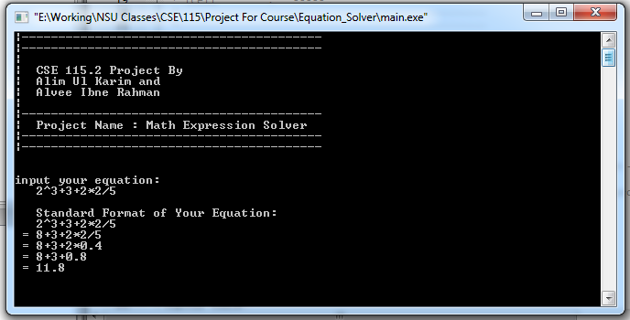

My expression solver can solve any simple expression but brackets are not done yet; after that the project will be done.

Alvee Rahman : Communication gap.